Port Questionnaire

*(to be filled out per ship per call!)*

|  |  |
| --- | --- |
| **Ship** | MS ARTANIA |
| **Port City** | Santa Cruz de La Palma – Canary Islands |
| **Date** | 09.11.2019 SATURDAY |
| **Arrival time** | 08:00 |
| **Departure time** | 14:00 |
| **Public Holiday** | Yes:  No: |
| **Name & Address of Port** | Port of Santa Cruz de La Palma |
| **Name/No of expected Berth** | Dique Este = East Dock (as usual) |

## Port Facilities

|  |  |
| --- | --- |
| Bank | Yes:  No: |
| Post Office | Yes: ☐ No: X |
| Shops | Yes: X No: ☐ |
| Tourist Information | Yes: ☐ No: X |
| Telephone | +34 922 41 21 21 / Handy +34 608 015 172 |
| Wi-Fi managed by Port Station Cafeteria | Yes: X No: ☐ FOC: X |
| Taxi stopped in front of ship | Yes: x No: ☐  Phone: +34 922 41 60 70 |
| Bus station | Yes:  No: X |
| Hop On / Hop Off | Yes: ☐ No: X |

## General Port Information

|  |  |
| --- | --- |
| * Distance to port exit * Is it allowed to walk inside the port?   + If no, is there a shuttle service? * Is it allowed to ride a bicycle inside the port area?   + If not, can they be carried in the shuttle? * Shuttle Service to the city centre * Is it allowed to bring any kind of food ashore? | * Between 300m and 1000m. * Yes: No: * Yes: No:  FOC: * Yes: No: * Yes: No: * Yes: No:  FOC: * Yes: No: |

## Country Information

|  |  |
| --- | --- |
| Currency | Klicken Sie hier, um Text einzugeben. |
| Accepted Payements:   * Only local currency: * Cash in US $ * Cash in € * Credit Cards * Maestro / Debit Card | * Yes: X No: * Yes: No: X * Yes: X No: * Yes: X No: * Yes: X No: |
| Postage   * Postcard * letter | * NORMAL SERVICE UNTIL 20GR 1,35€ EUROP YEAR 2018   NORMAL SERIVE UNTIL 20GR 1,35€ EUROP YEAR 2018 |
| Typical Souvenir | CIGARRS, RUM, WINE, |

## Distances

|  |  |  |  |
| --- | --- | --- | --- |
| * City Center * Next recommendable beach * Airport * Main Station | * In front of Port * Town sea front * **Code SPC** * Bus Station | km: 0,5 Km  km: 1 Km  km: 10 Km  km: 0,6 Km | Taxi fare: aprox. 10€  Taxi fare: aprox. 10€  Taxi fare: aprox. 12€  Taxi fare: aprox. 10€ |

## General Information

|  |  |  |
| --- | --- | --- |
|  | Where: | Business/Opening Hours: |
| Tourist Information | * In front of Port Entrance North - City | * Mo-Fr 09:00-14:00 Mo-Fr 15:00-18:00 Sat-Sun 09:00-13:00 |
| Post Office | * At left after Port Entrance | * Mo – Fr 08:30 – 20:30 Sat 08:30 – 13:30 |
| Shopping | * In fornt of Port Entrance Nort - City | * Mo – Fr 09:00 – 13:30 Mo - Fr 16:30 - 19:30 Sat 09:00 – 13:30 Sun 09:30 – 13:30 only souvenier shops |
| Museums | * Maritim Museum – Columbus Ship | * Mo – Fr 10:00 – 18:00 Sat – Sun 10:00 – 14:00 |
| Restaurants | * City Centre. | * 11:00-15:30 // 18:00-23:00 Most of Rest. Closed on Sun. |
| Places of interest: | * Town Centre, Old Town. | * 08:30 – 20:00 Buisness Time |
| Shuttle services FOC | * Only for ships wiht more than 2000passengers | * One houre after ship arriv. Unitl 30min ship departure |

## Special Remarks

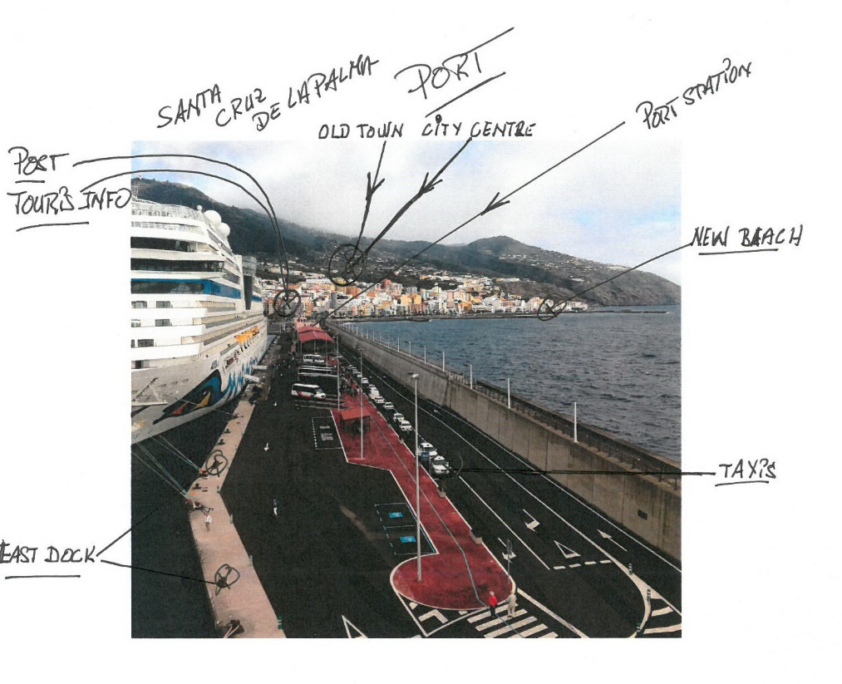Passengers must only follow the blue line to go into the town centre where are Tourist Office, Post, Shops, Banks, Pharmacies, etc.